Online Advertising Performance Analysis of Company X

Made by: Prashanth S

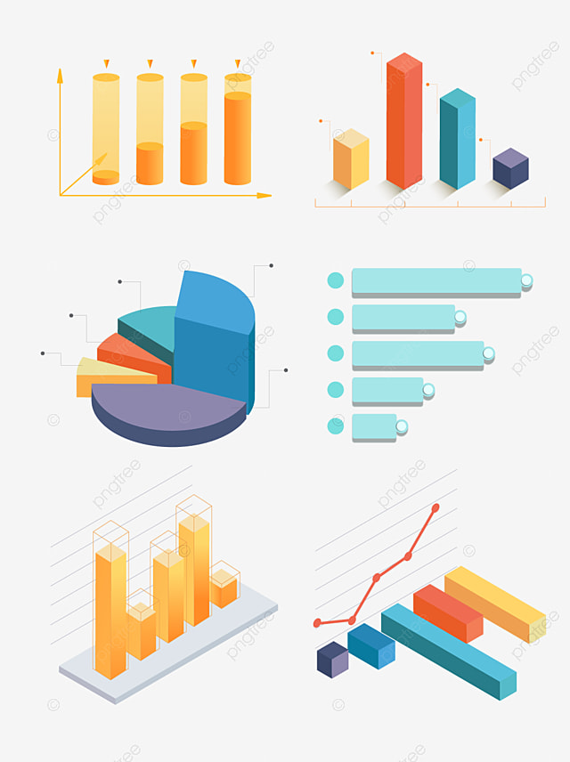

# Introduction to Ad Optimization

In today's competitive digital landscape, optimizing online ads is essential for maximizing return on investment (ROI). This presentation will delve into the performance of Company X's online advertising campaign, using data-driven insights from April to June 2020. We will explore how various factors—such as ad size, placement, and user engagement—impact overall ad effectiveness, and provide strategies to enhance future campaign performance and better reach the target audience.

**Insights into Company X**

**1.Overall user involvement 2.Ads and Conversion 3.Cost and revenue**

**4.Campaigns with high conversions**

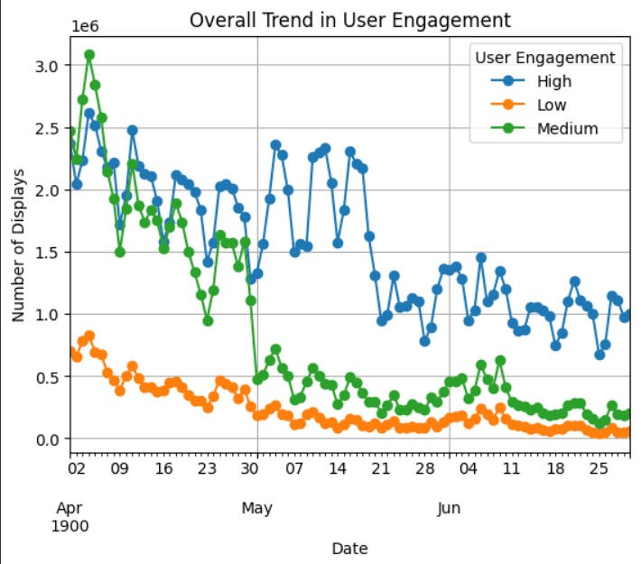

**Trends in user involvement**

This line graph shows the total post-click sales amounts over time from early April to late June. The trend seems to indicate a general decline in post-click sales over this period, with some ﬂuctuations. Early on, the sales amounts were higher, often exceeding 450,000, but they steadily decreased towards the end of June, where they ﬂuctuate around 250,000 to 350,000.

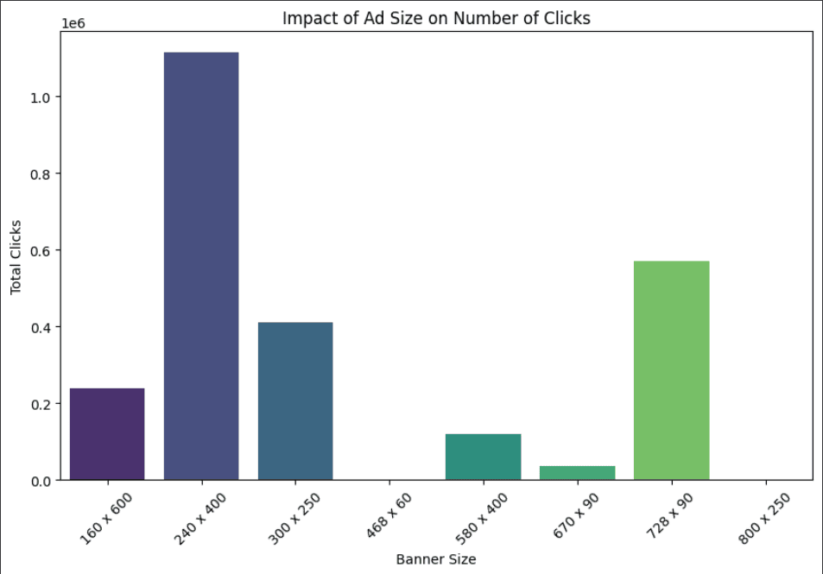

# Ads and conversions

This bar chart depicts the relationship between different banner ad sizes and the total number of clicks they received. The 240x400 size banner clearly outperformed the others, with over 1 million clicks. The 728x90 banner is the second most effective, followed by 300x250 and 580x400. The 160x600, 468x60, and 670x90 sizes had signiﬁcantly fewer clicks, indicating that these sizes may be less effective.

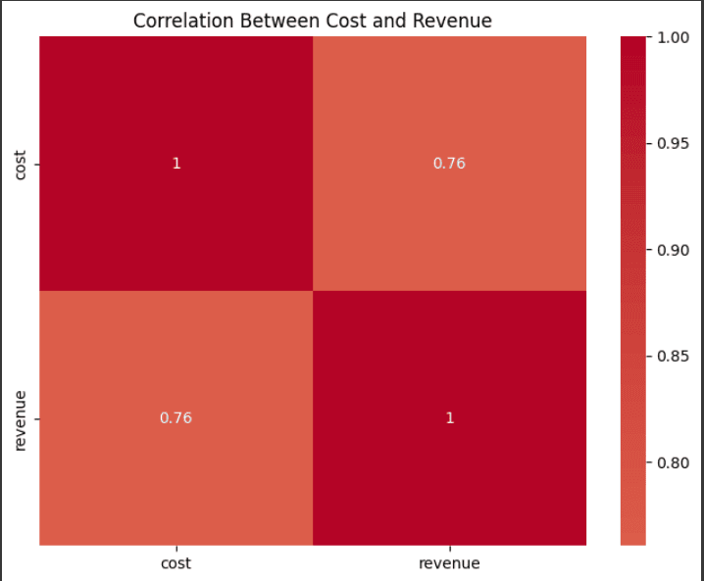

# Cost and revenue (Correlation)

This bar chart depicts the relationship between different banner ad sizes and the total number of clicks they received. The 240x400 size banner clearly outperformed the others, with over 1 million clicks. The 728x90 banner is the second most effective, followed by 300x250 and 580x400. The 160x600, 468x60, and 670x90 sizes had signiﬁcantly fewer clicks, indicating that these sizes may be less effective.

**User Engagement Levels: Weekdays vs. Weekends**

This line chart compares user engagement levels between weekdays and weekends. Weekdays generally show higher engagement across most levels, while weekends have lower engagement. This trend suggests that ad effectiveness varies with the day of the week, potentially influencing how ad strategies should be optimized.

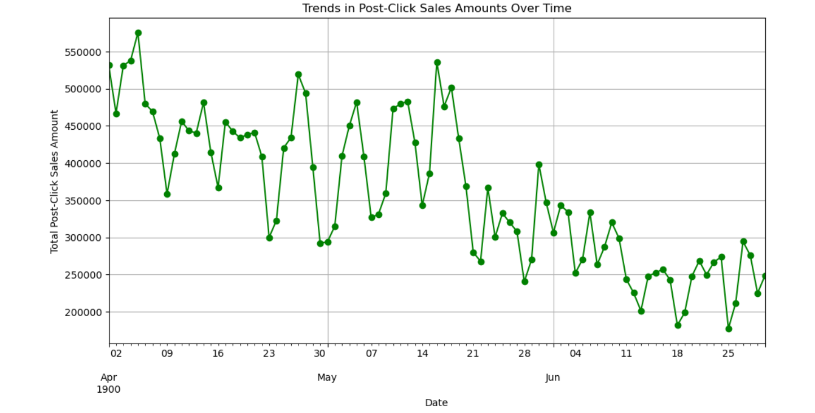

Thanks!